1. File 🡪 New 🡪 Web Service Project

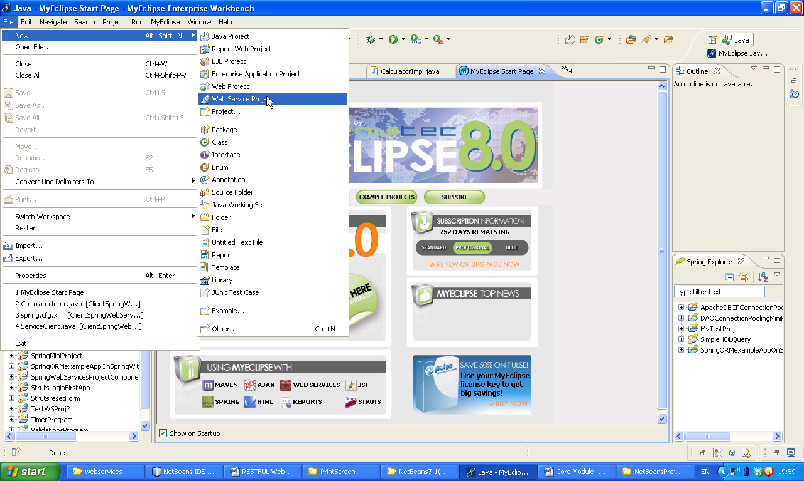Now Give Project name 🡪 RESTComponentDealingWithXML 🡪 select REST(JAX-WS) 🡪 Finish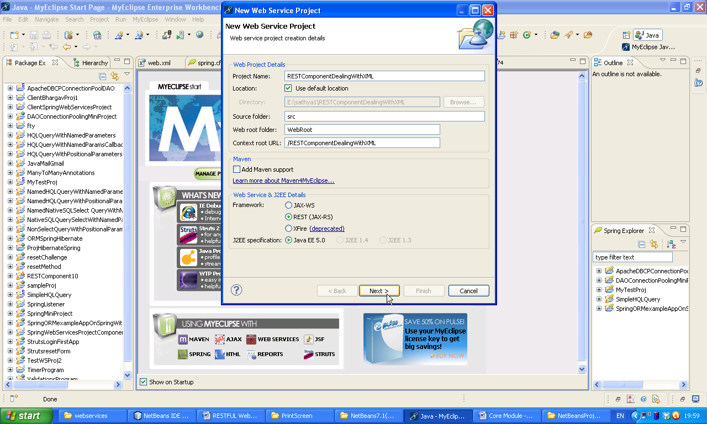

Now select all libraries 🡪 Finish

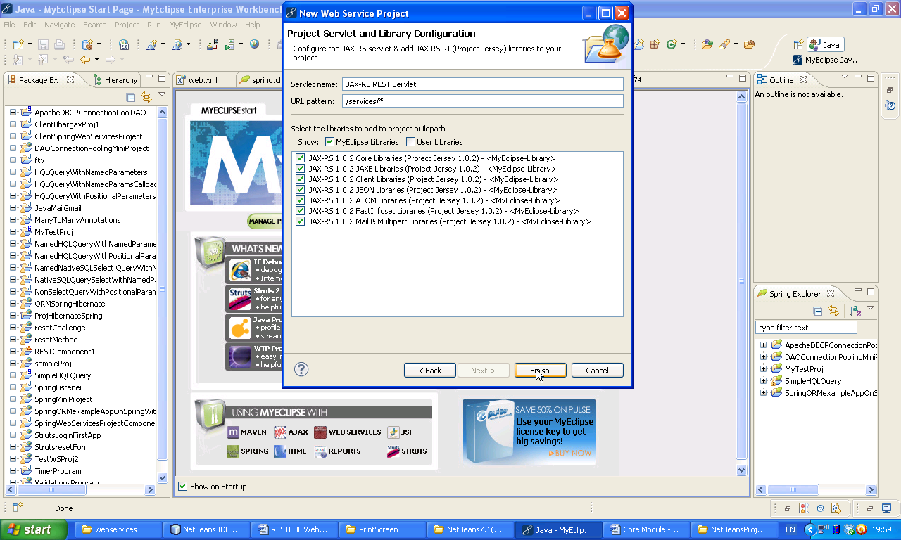Select No here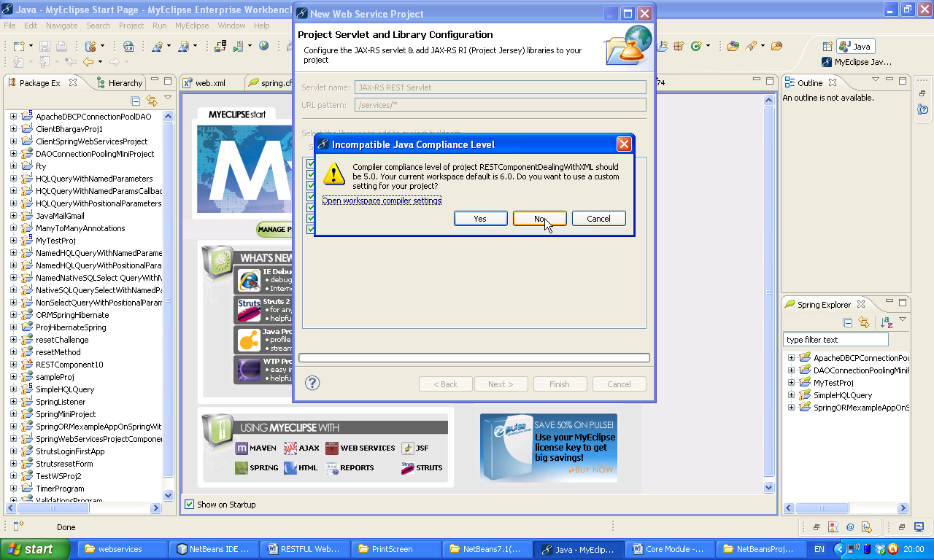

Now take a class

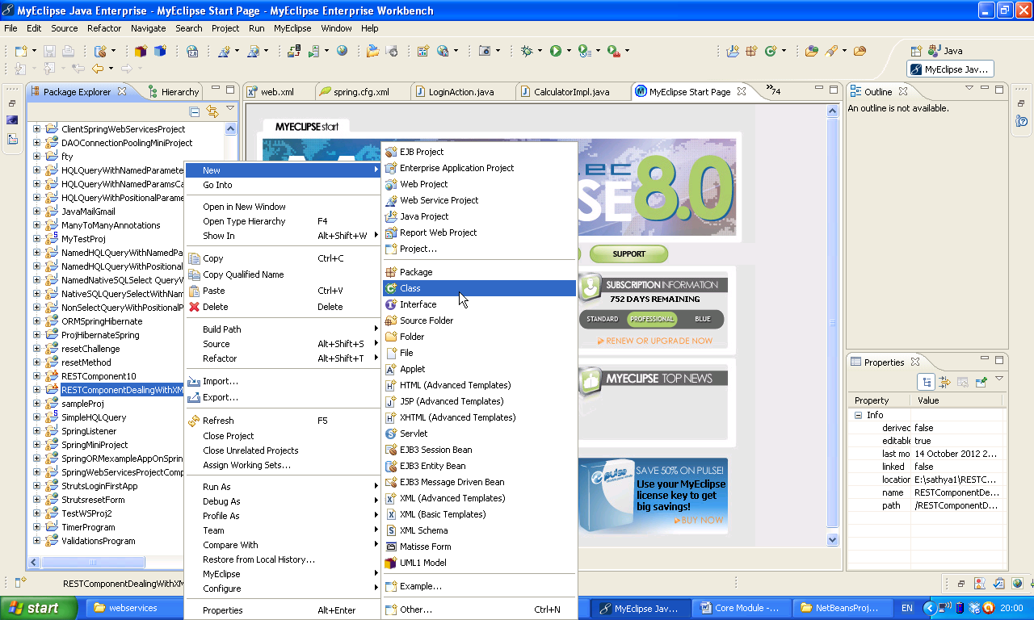Give class name 🡪 Customer, Package:p1 🡪 Finish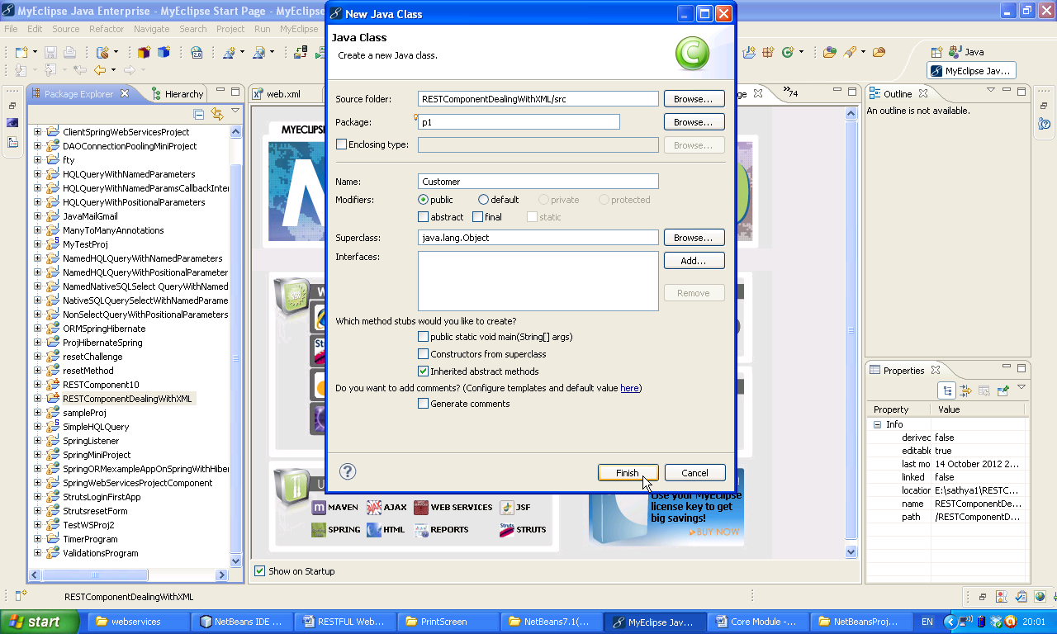

Now following window will appear

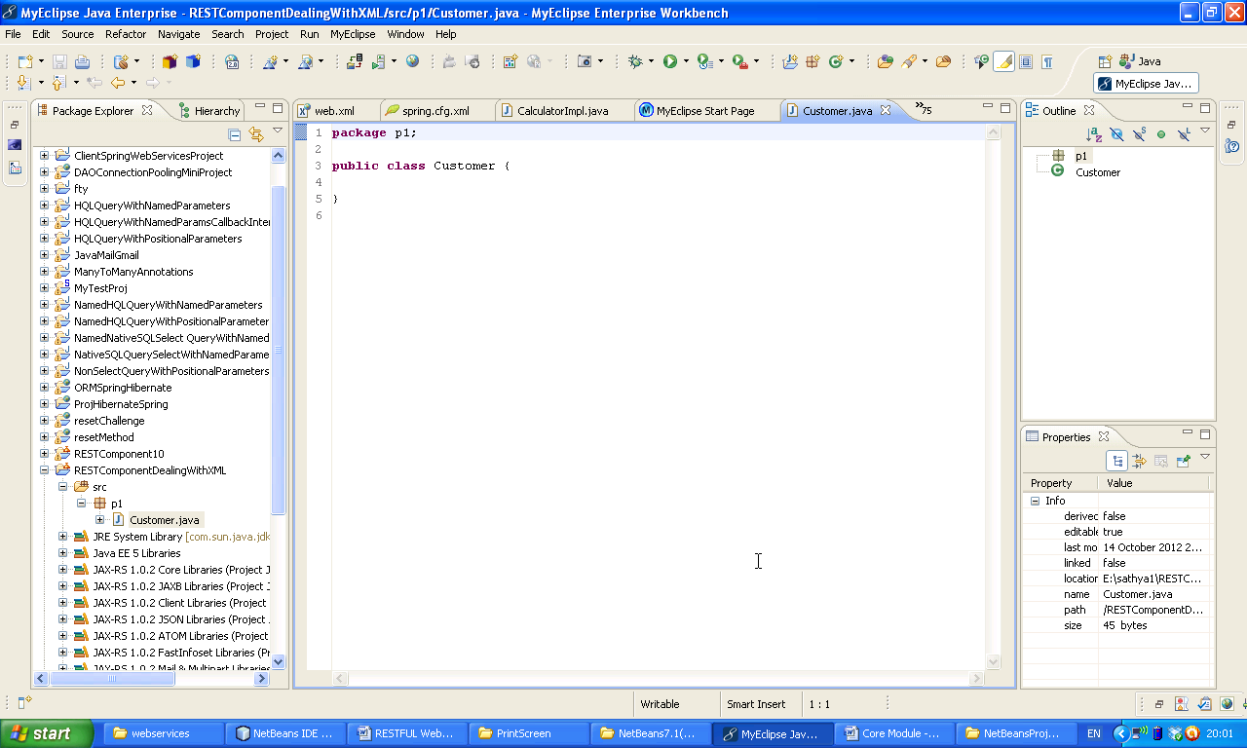Paste the following code.

**package** p1;

**import** javax.xml.bind.annotation.XmlRootElement;

@XmlRootElement

**public** **class** Customer {

**private** **int** id;

**private** String name;

**private** String address;

**public** **int** getId() {

**return** id;

}

**public** **void** setId(**int** id) {

**this**.id = id;

}

**public** String getName() {

**return** name;

}

**public** **void** setName(String name) {

**this**.name = name;

}

**public** String getAddress() {

**return** address;

}

**public** **void** setAddress(String address) {

**this**.address = address;

}

}

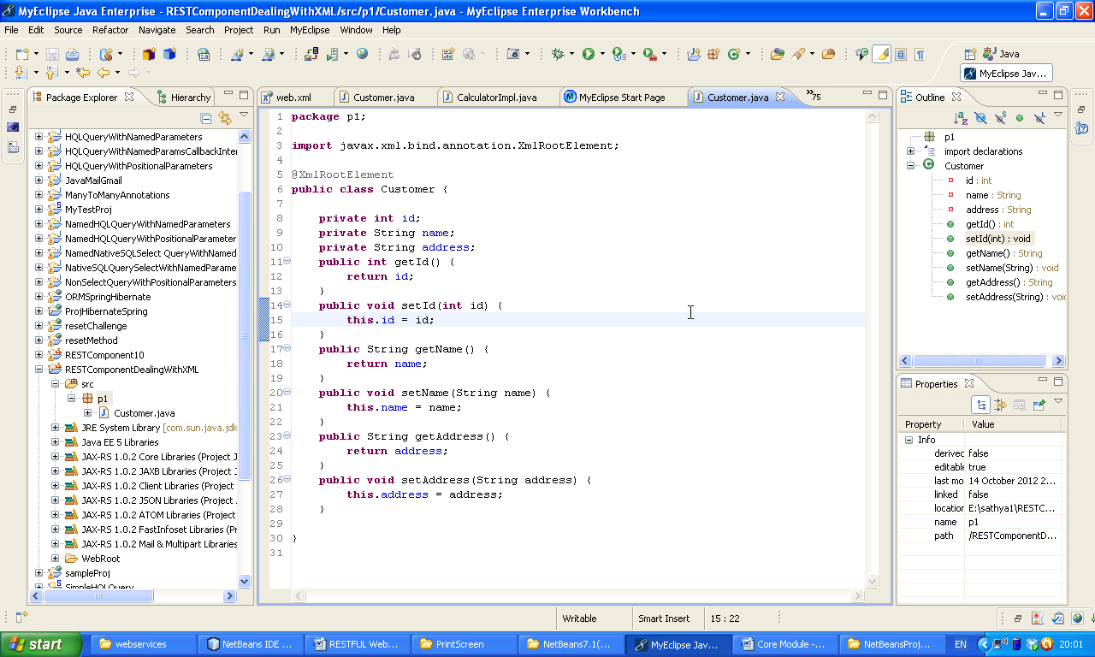

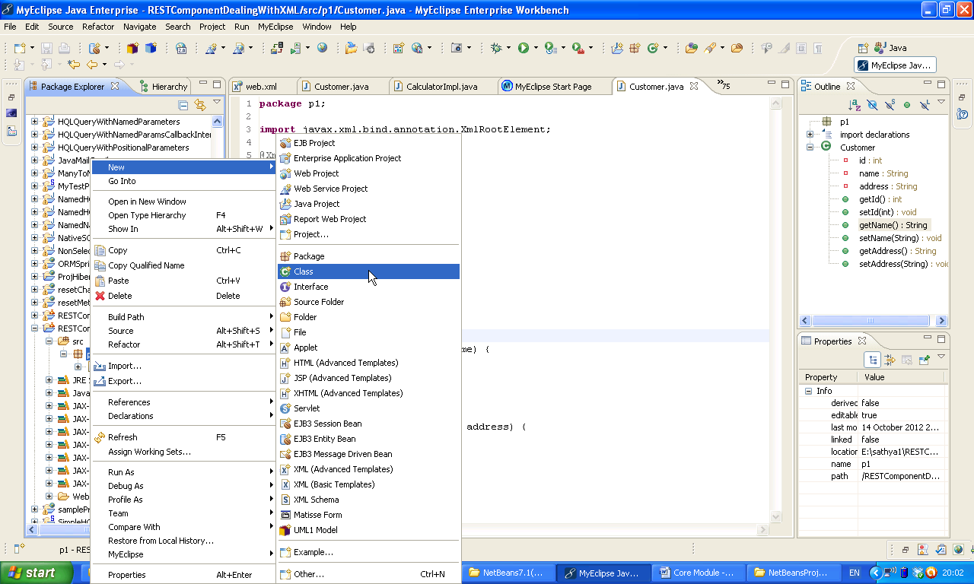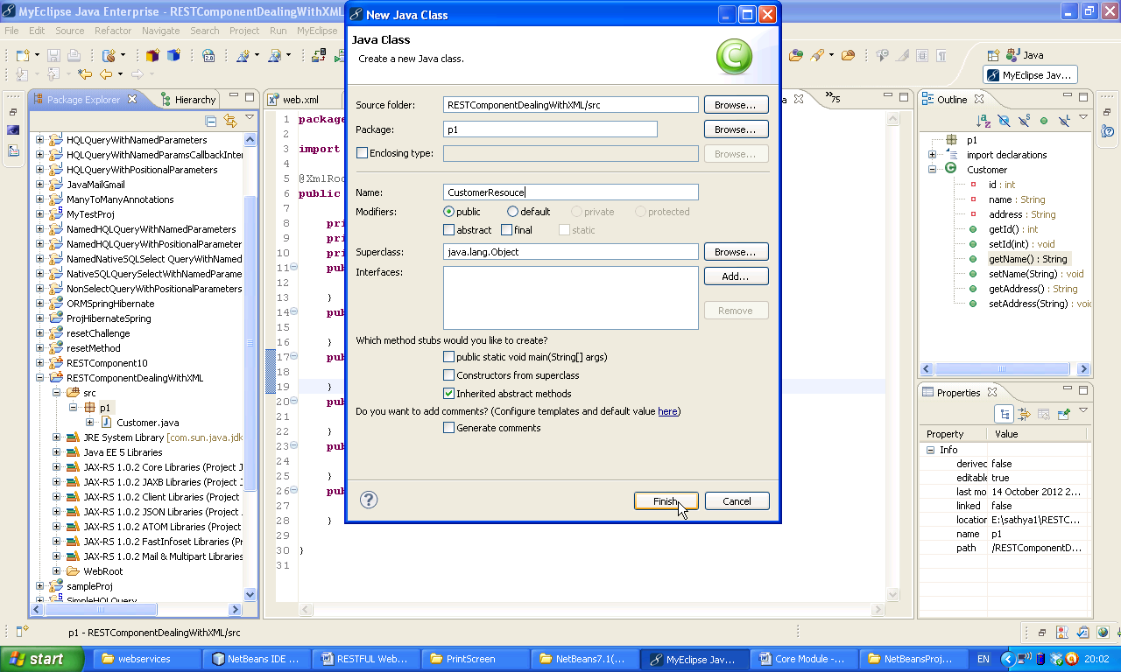

Now take another class CustomerResource

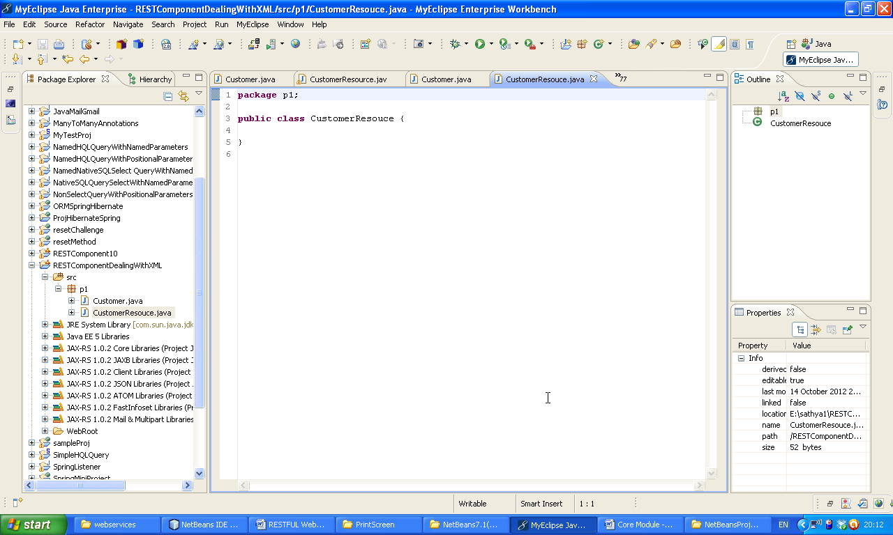Now we have to convert customer resource to Web Service Resource. Right click on the project 🡪 New 🡪 Other.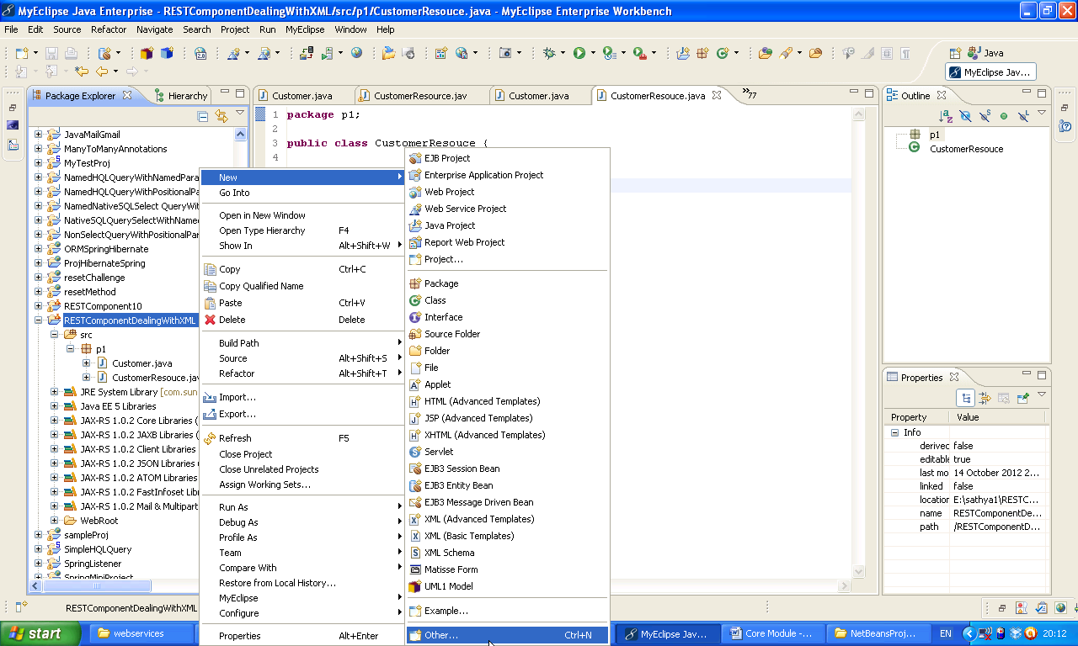

Choose MyEclipse 🡪 expand

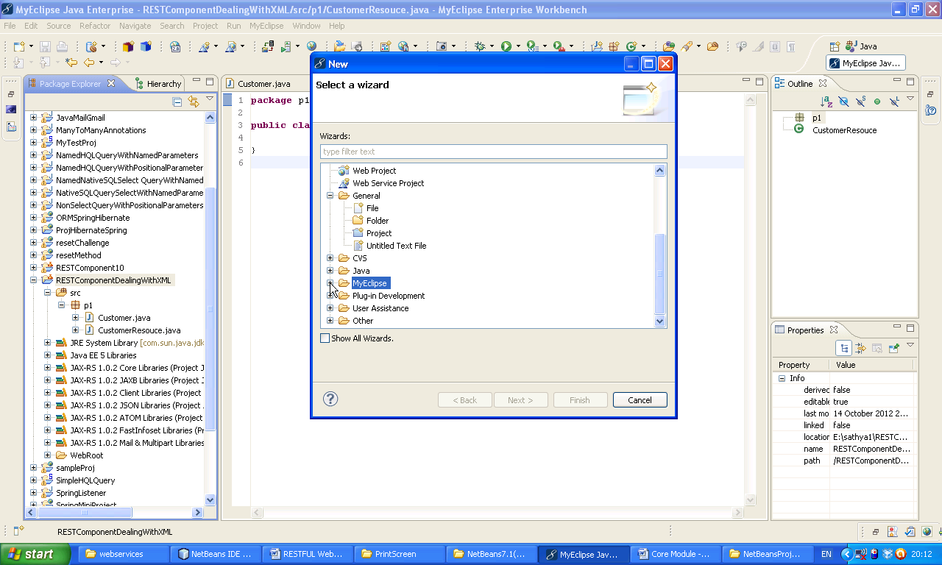Now expand Web Services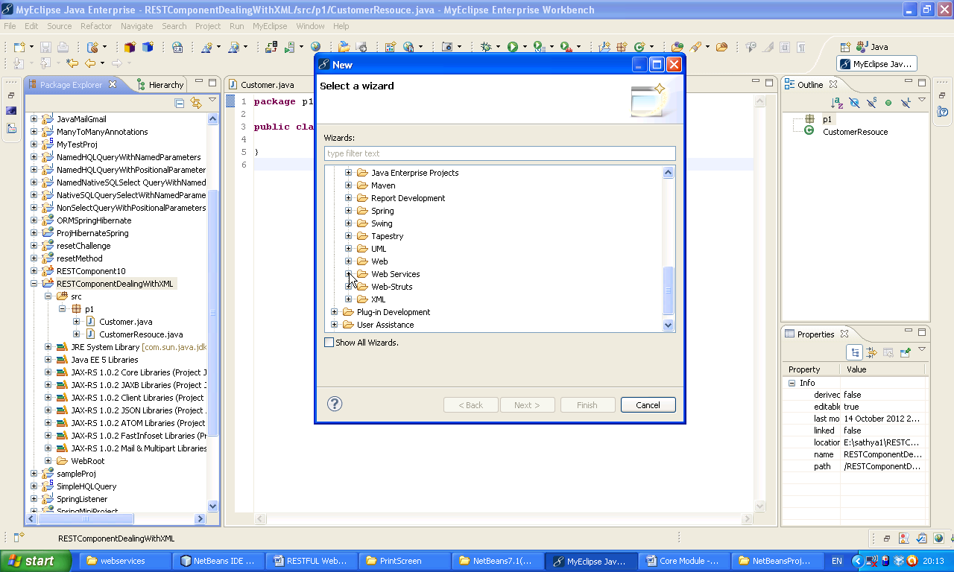

Select Web Service

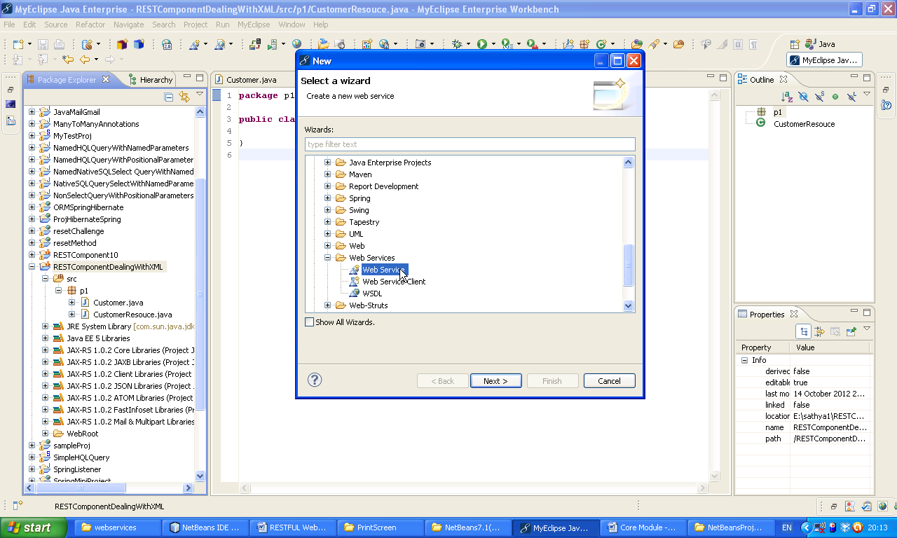 Next 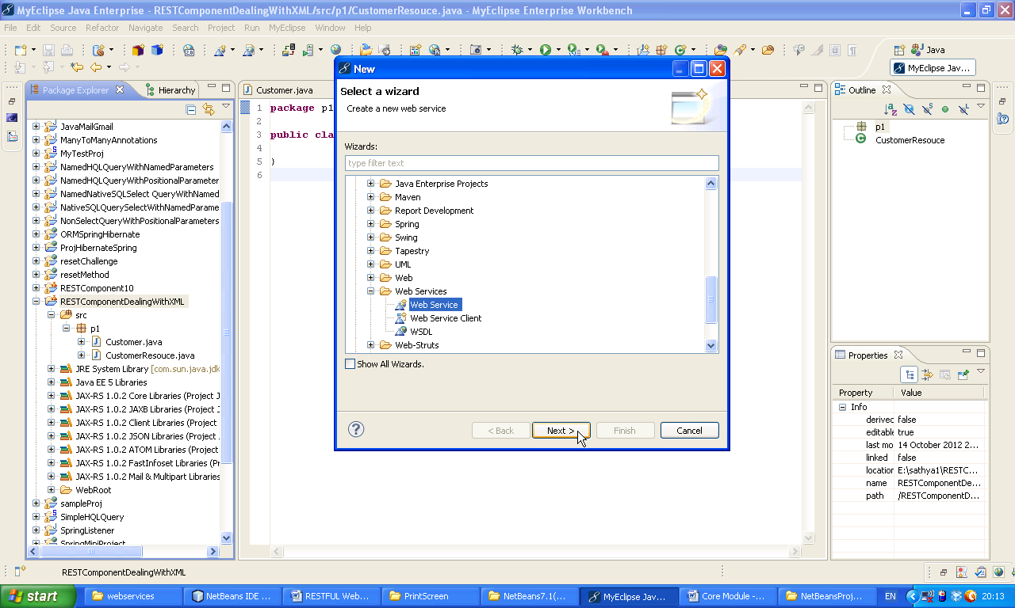

Select REST(JAX-WS) 🡪 Next

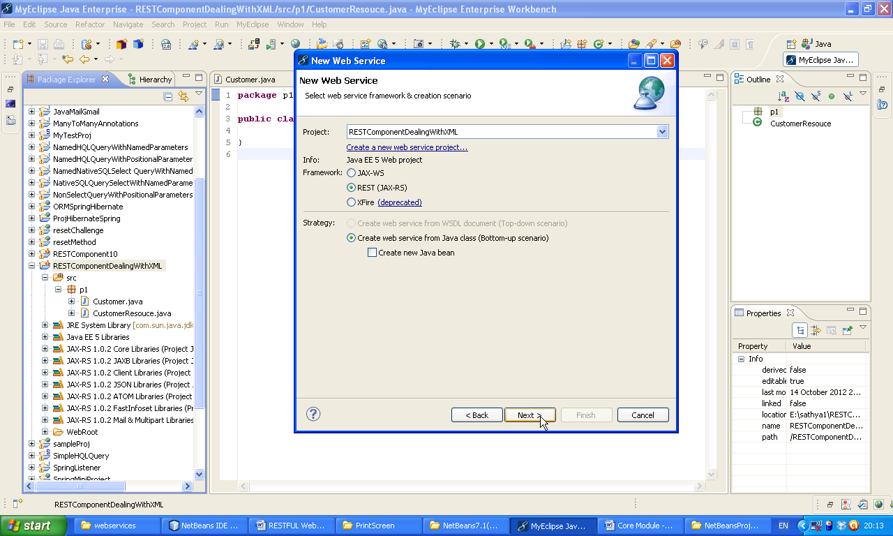Now fill up all details as shown below 🡪 Add

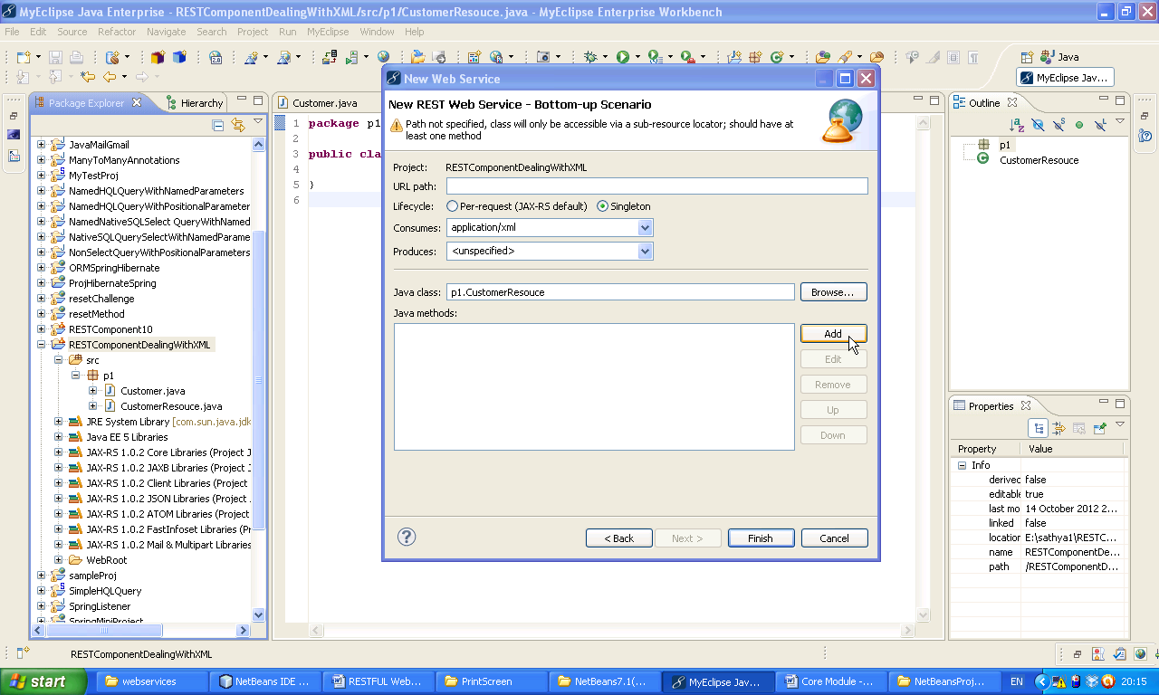

Now fill up all details as shown below 🡪 (before clicking finish check all details once) Finish

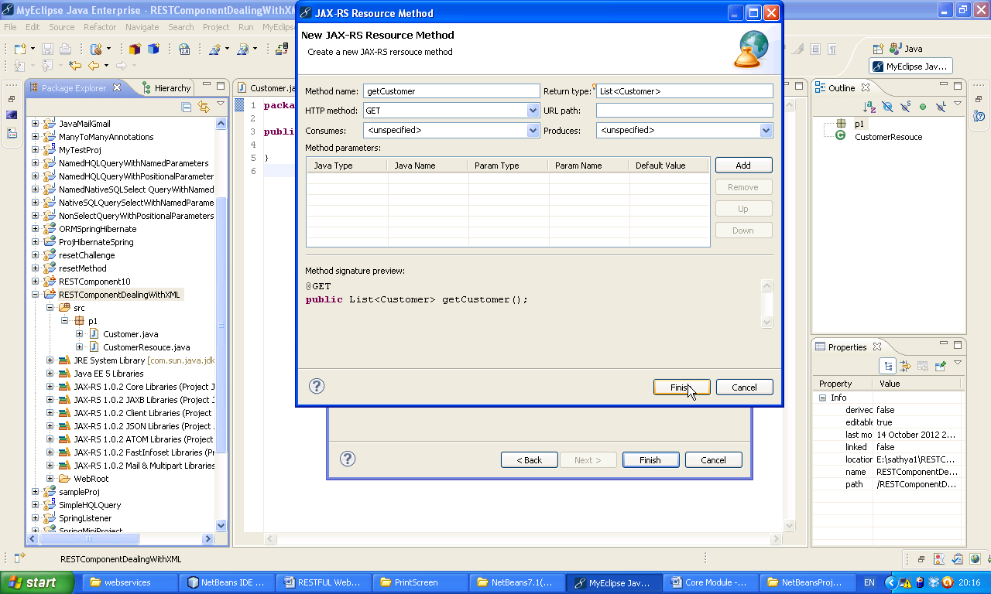Now Click on Add 🡪 fill up all details as shown below 🡪 Click Add 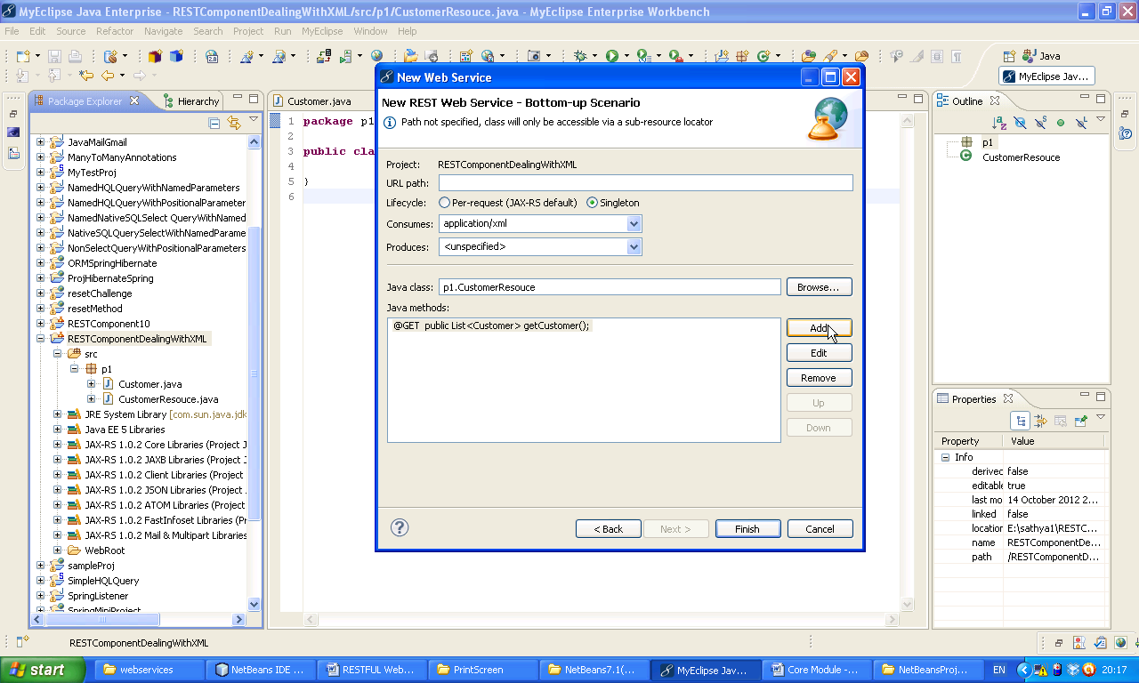

Now fill up all details as shown below 🡪 Click on Add

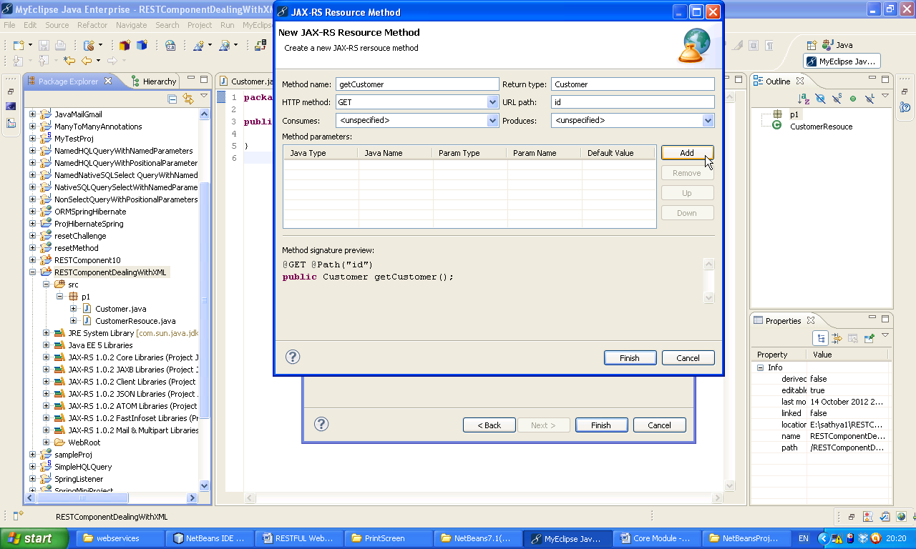Now fillup job type, Java Name, Param Type, Param Name as shown below 🡪 (before clicking finish check all details once) Finish 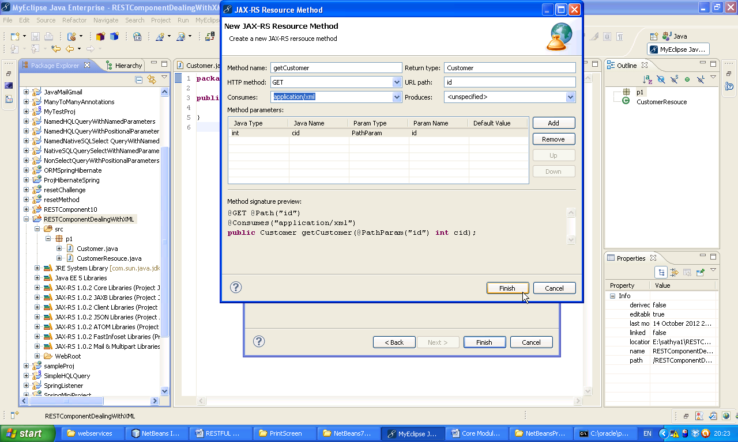

Now again Click on Add.

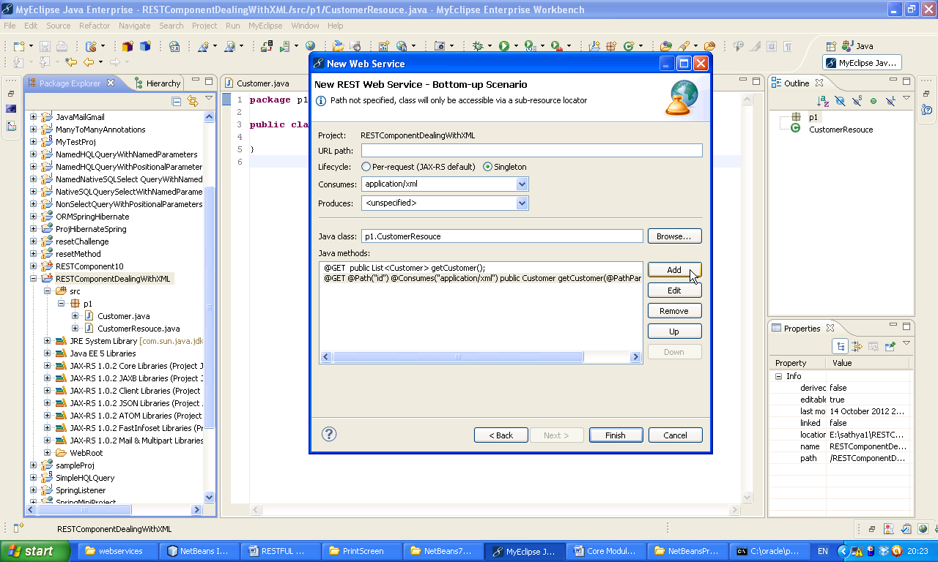fill up all details as shown below 🡪 Finish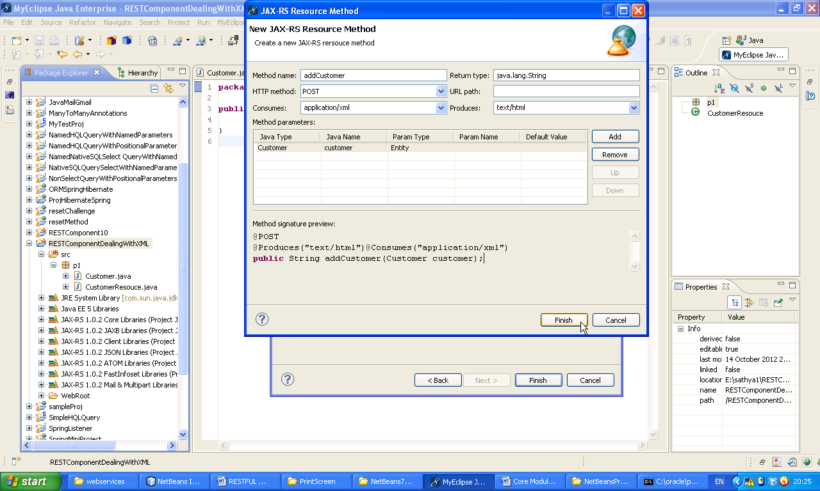

Click Finish

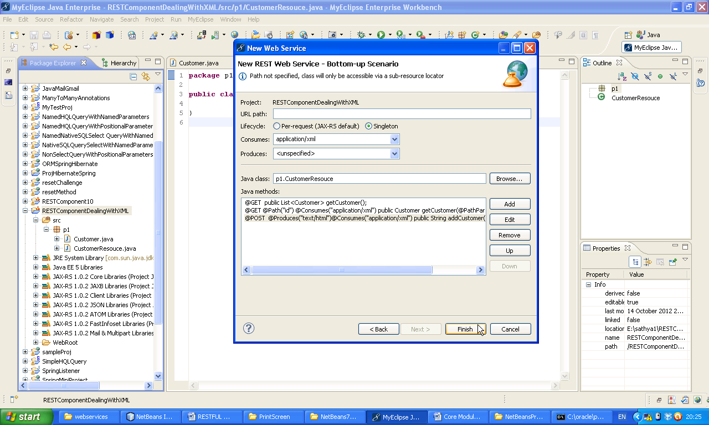Now the following code will appear with one error message.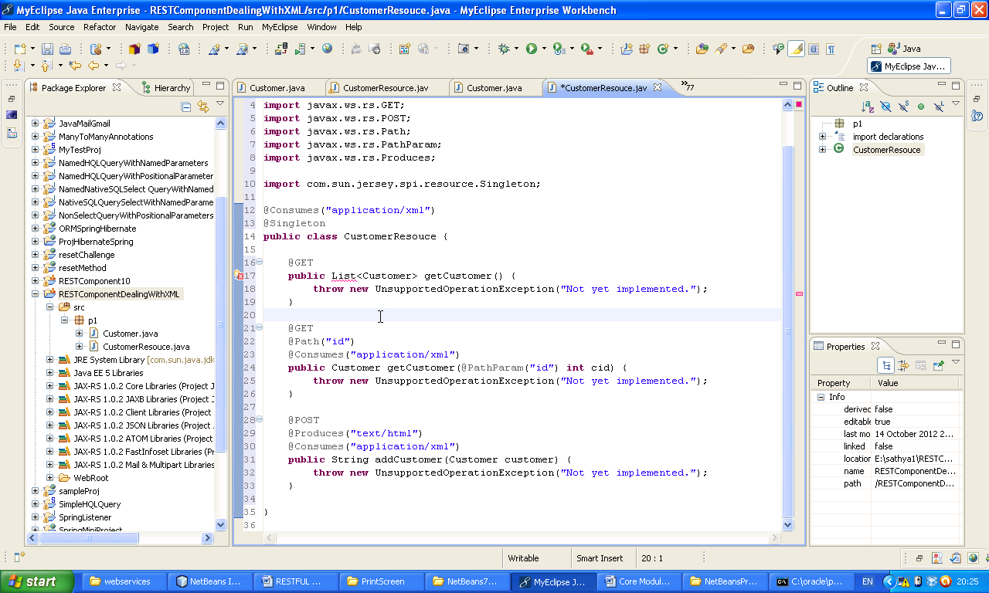

Press Ctrl+Shift+O then following window will appear 🡪 select java.util.List 🡪 Clcik Finish

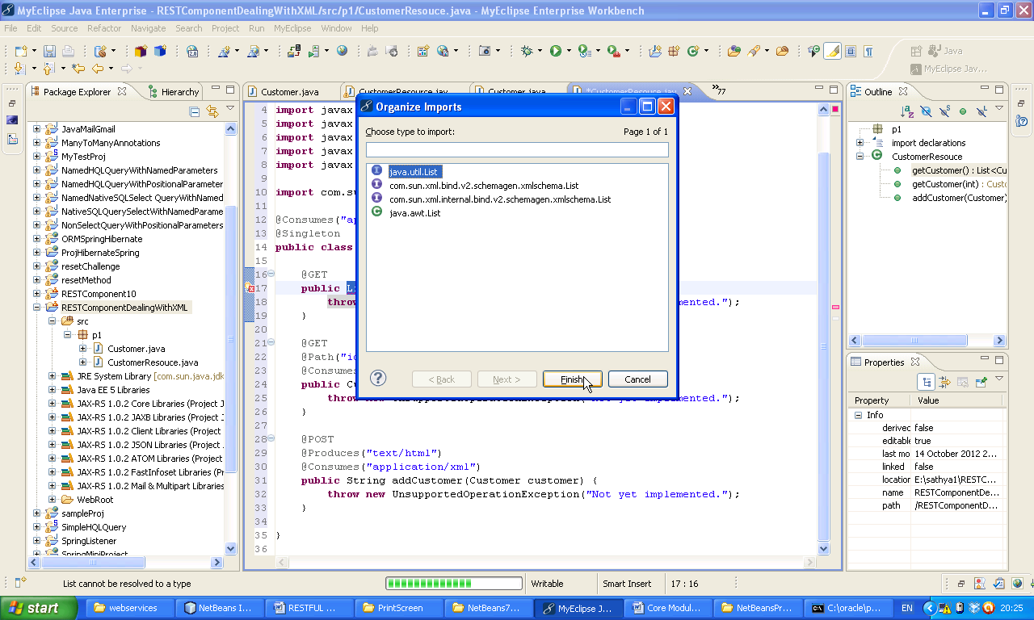Now Right click on the project 🡪 Build Path 🡪 Add External Archives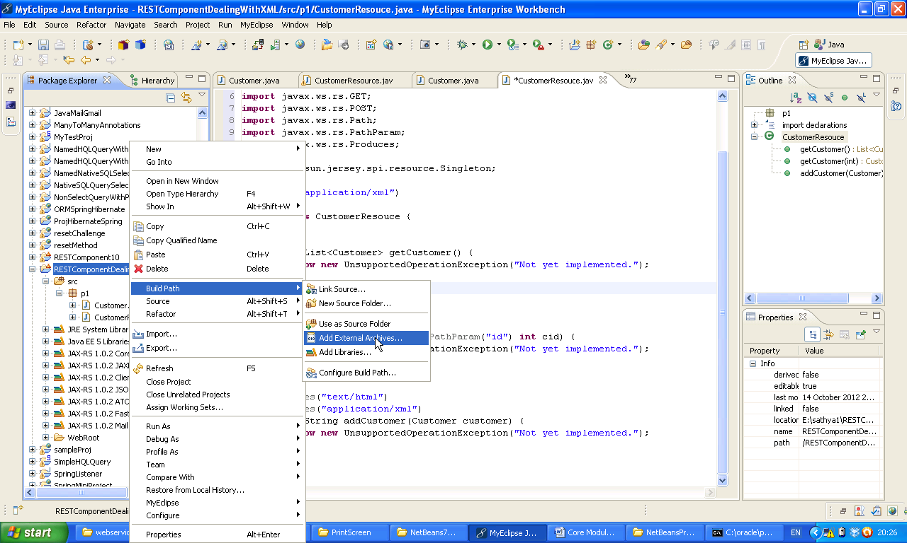

Now select ojdbc14.jar 🡪 Open

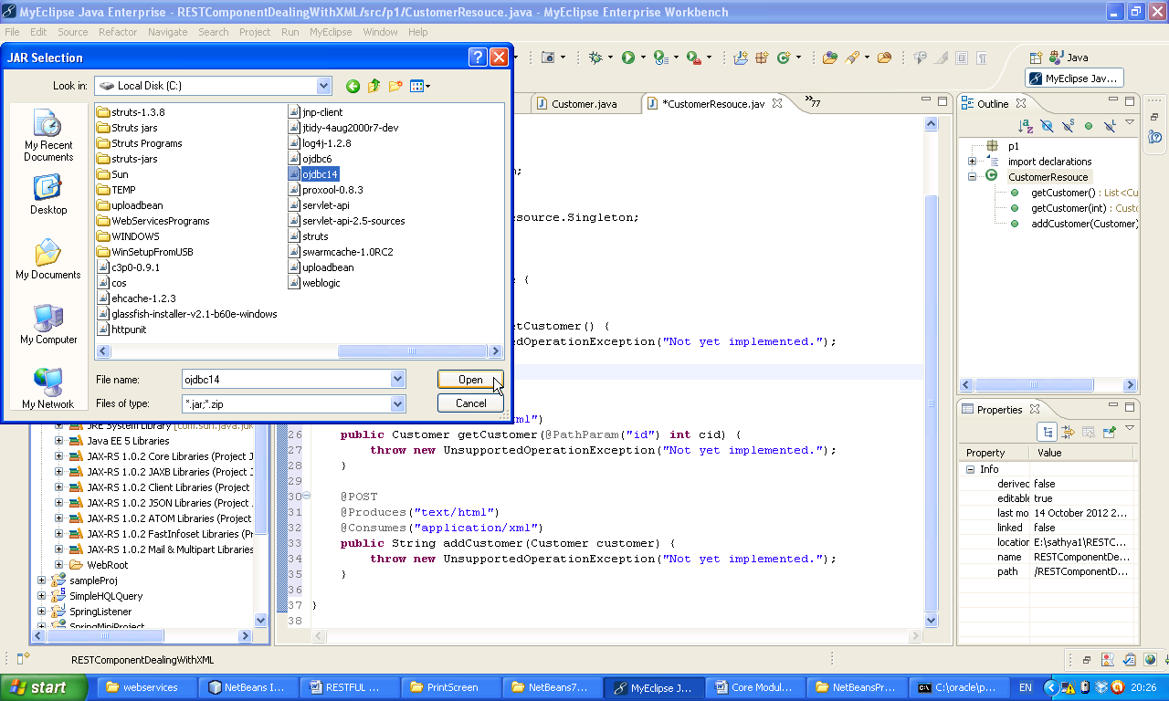Now Right click on the project 🡪 Run As 🡪 My Eclipse Server Application.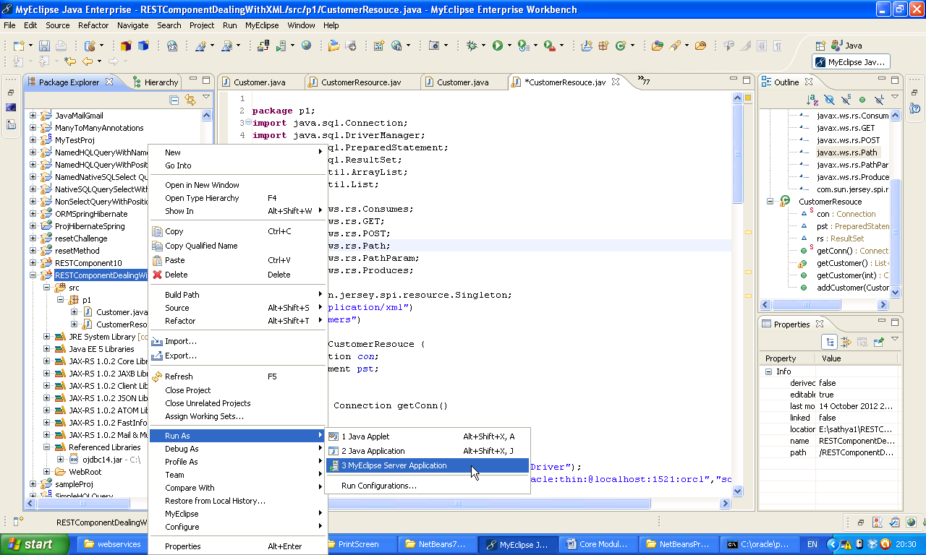

Select Tomcat 6.X.

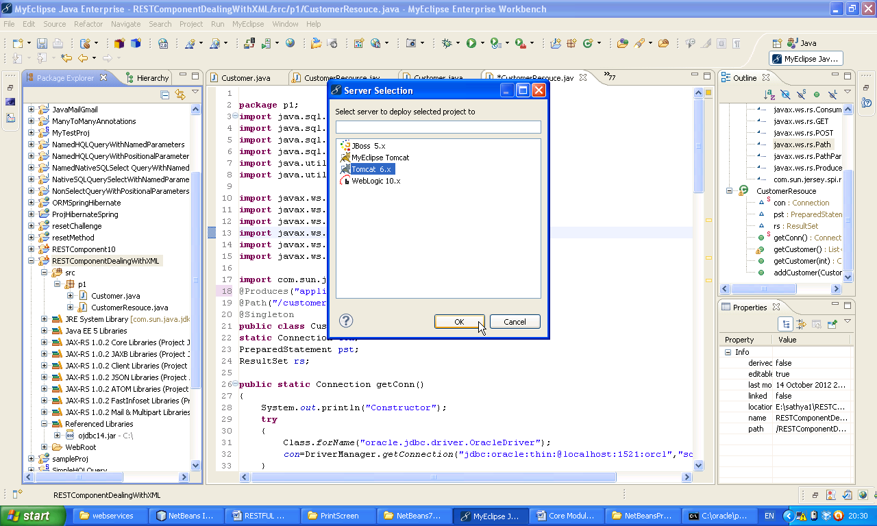Now observe Server startup

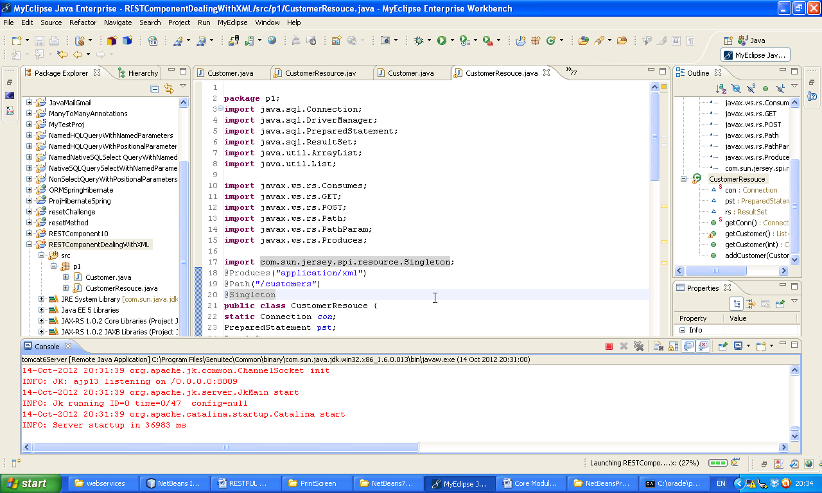

**Client Application**

Now Create a Java Project 🡪 give name 🡪 ClientProjectForRESTComponentDealingWithXml 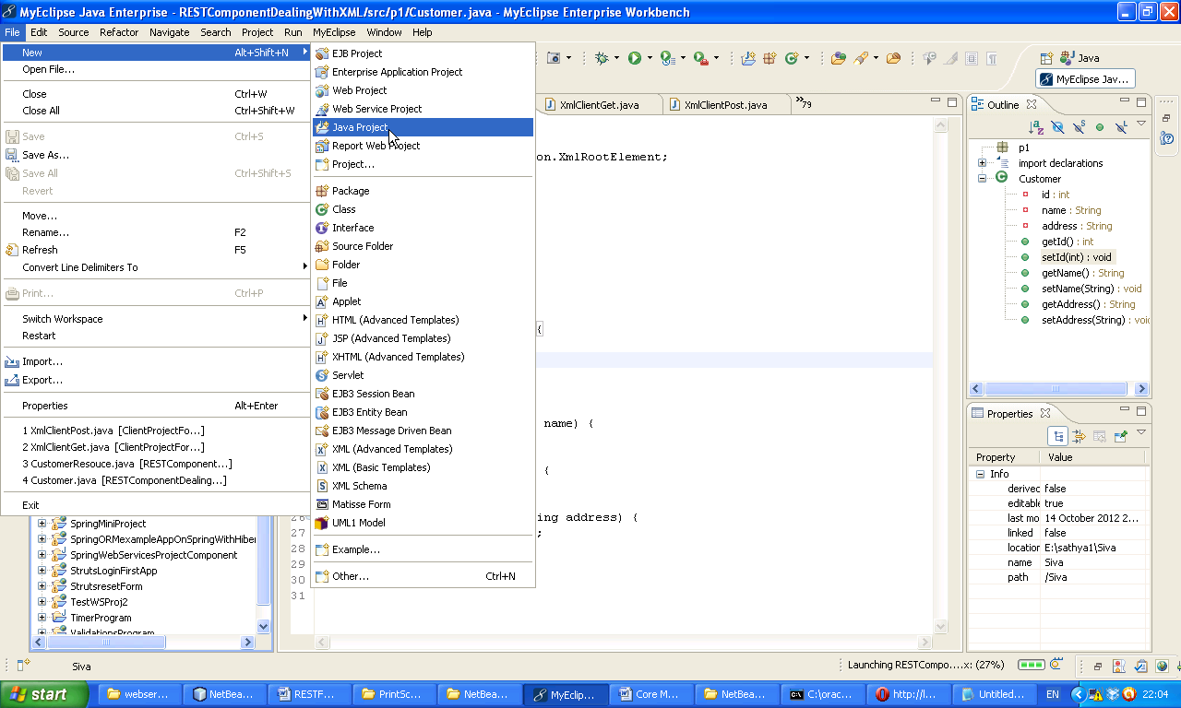

Now create a class Right Click on the project 🡪 Class

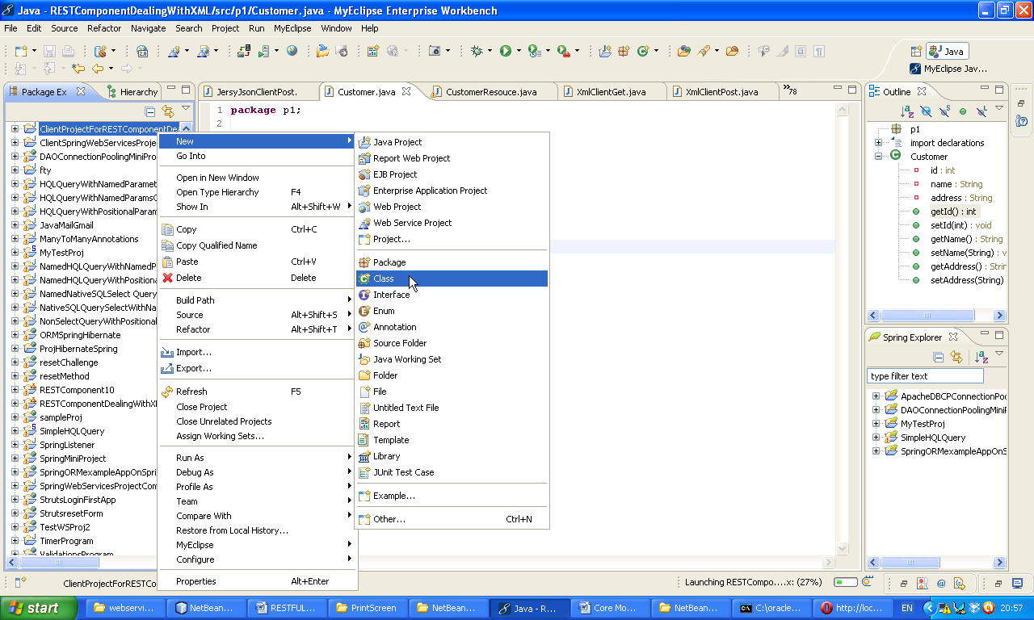Give class name as XmlClientGet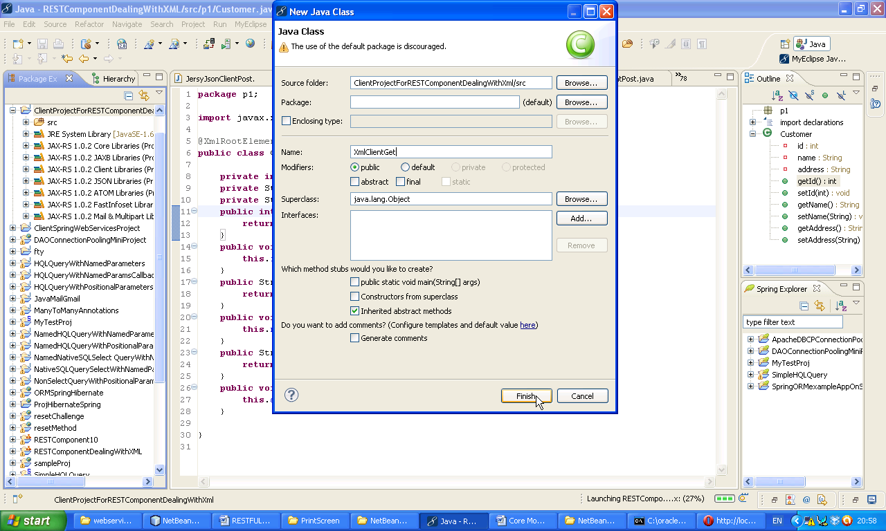

Now following window will appear

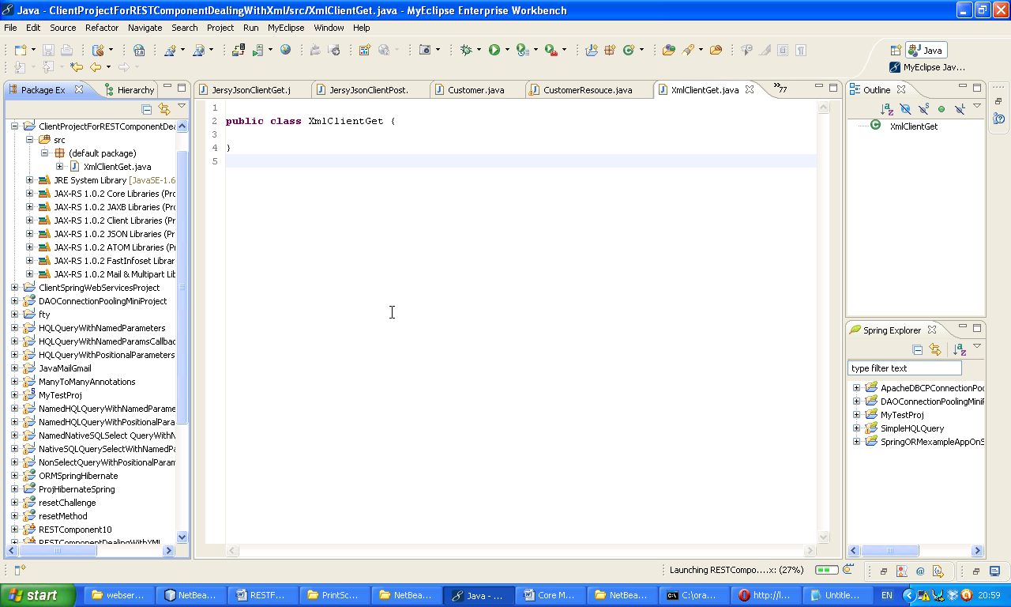Now paste following code.

**import** com.sun.jersey.api.client.Client;

**import** com.sun.jersey.api.client.ClientResponse;

**import** com.sun.jersey.api.client.WebResource;

**public** **class** XmlClientGet

{

**public** **static** **void** main(String[] args)

{

**try**

{

Client client=Client.*create*();

//shows the all customer list in Json form

WebResource webResource=client.resource("http://localhost:5050/RESTComponentDealingWithXML/services/customers");

ClientResponse response=webResource.accept("application/xml").get(ClientResponse.**class**);

**if**(response.getStatus()!=200)

{

**throw** **new** RuntimeException("Failed: HTTP error code"+response.getStatus());

}

String output=response.getEntity(String.**class**);

System.*out*.println(output);

}

**catch**(Throwable e)

{

e.printStackTrace();

}

}

}

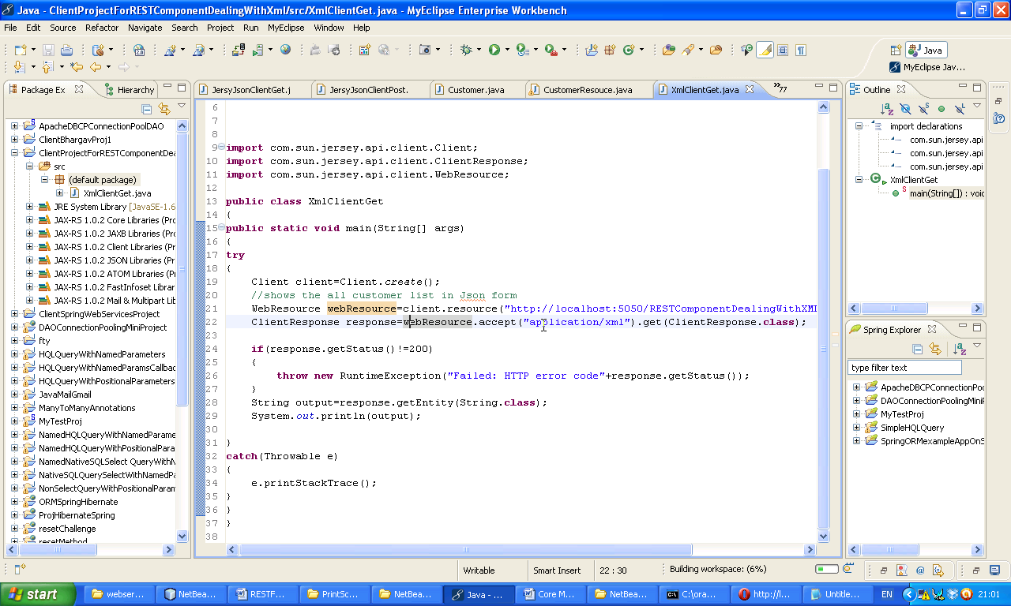

Now Right Click on the project 🡪 Select class.

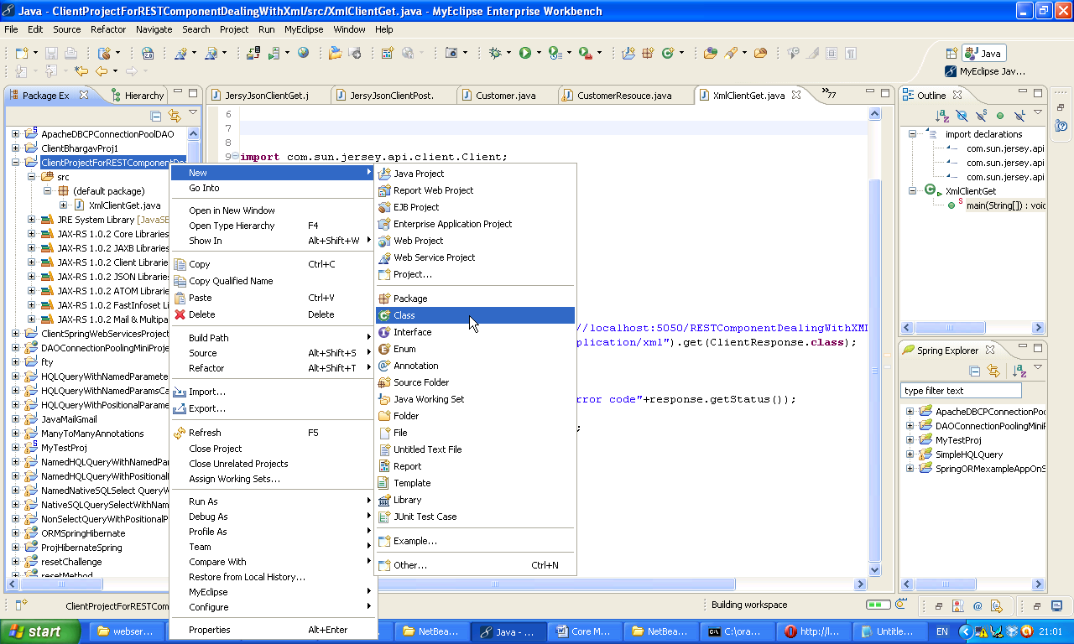Now give class name 🡪 XmlClientPsot 🡪 Finish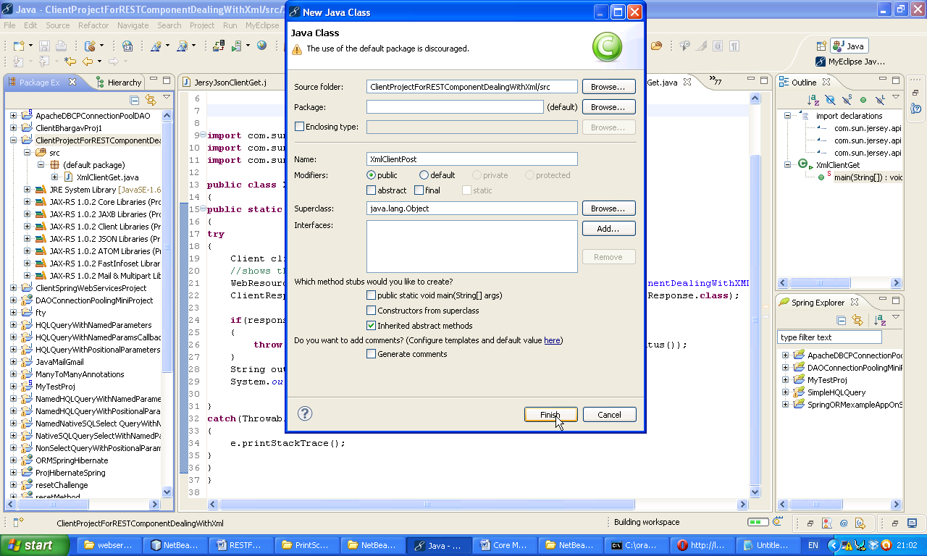

Now Right click on the XmlClientGet.java 🡪 Run Java Application

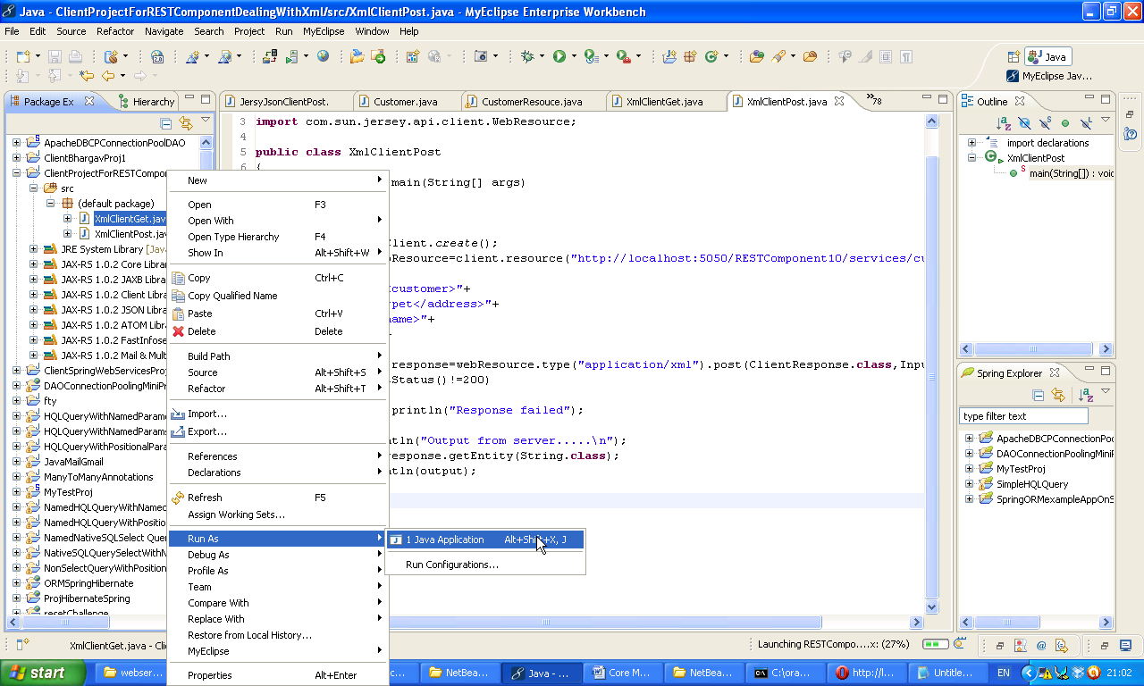Now following window will appear with XML content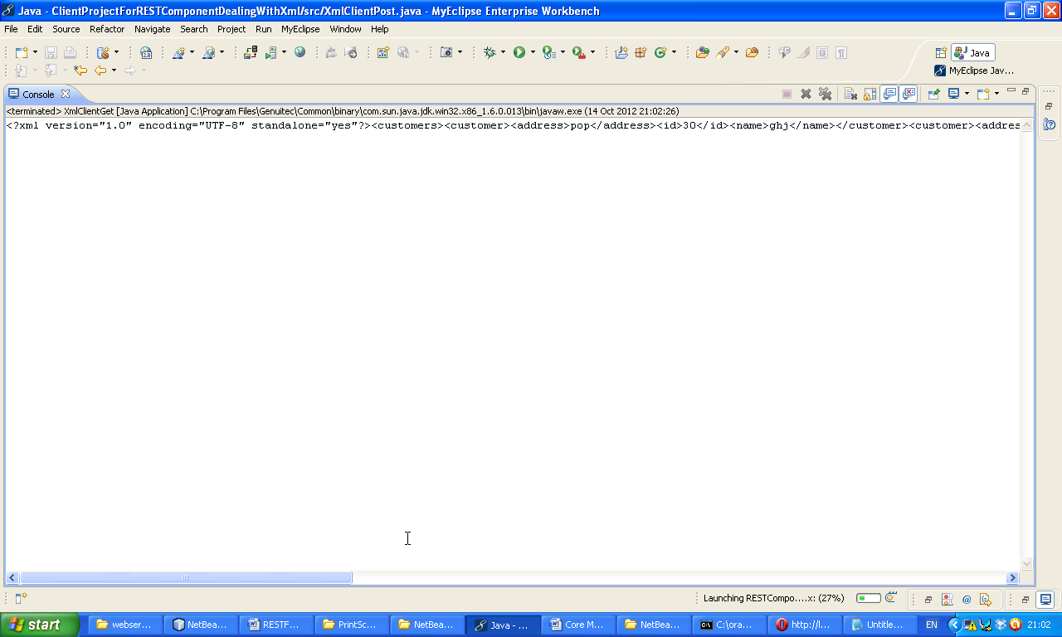

Now create another class

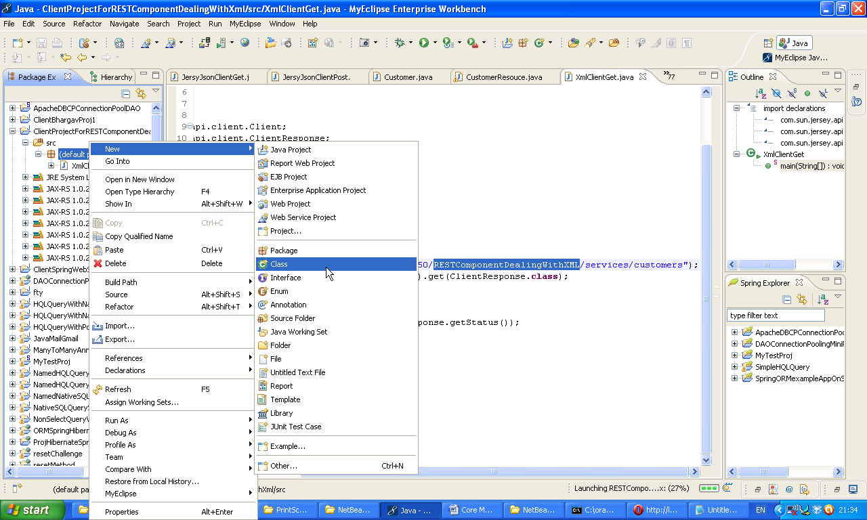Give class name 🡪 XmlClientPost 🡪 Finish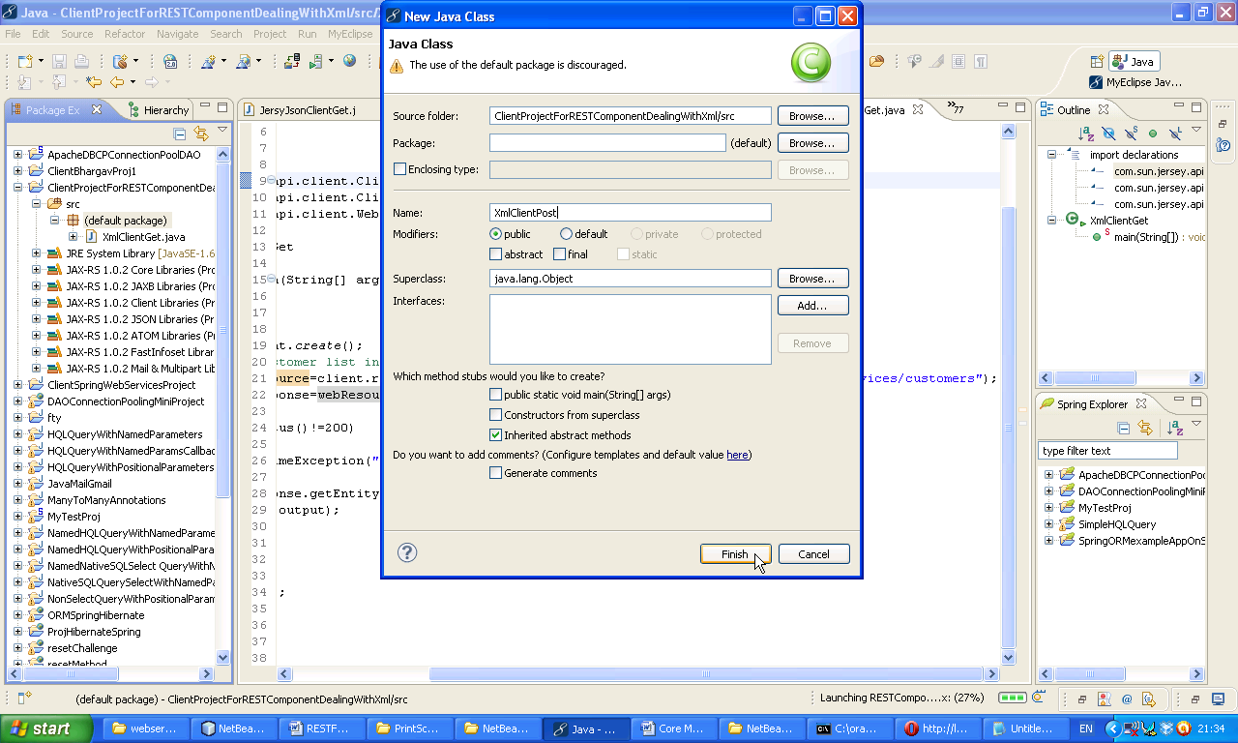

Now following window will appear

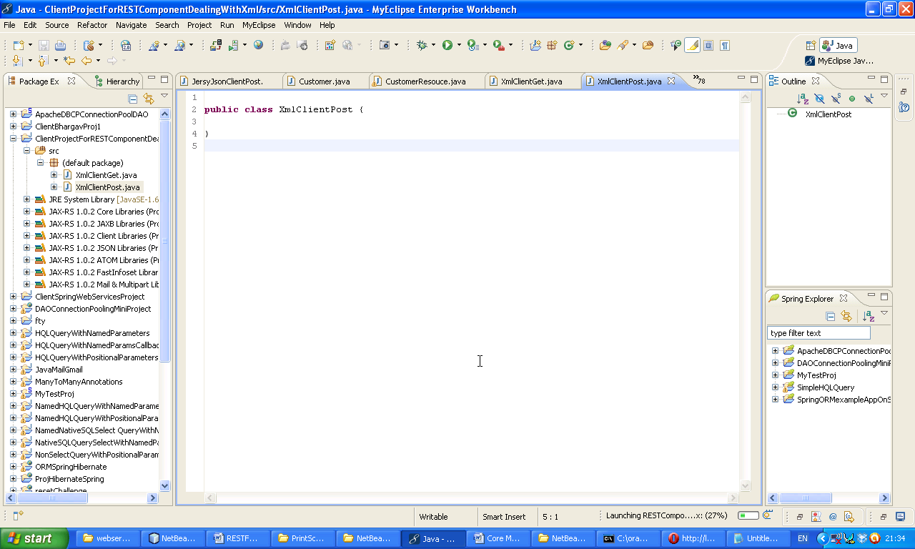Now paste following code here.

**import** com.sun.jersey.api.client.Client;

**import** com.sun.jersey.api.client.ClientResponse;

**import** com.sun.jersey.api.client.WebResource;

**public** **class** XmlClientPost

{

**public** **static** **void** main(String[] args)

{

**try**

{

Client client=Client.*create*();

WebResource webResource=client.resource("http://localhost:5050/RESTComponentDealingWithXML/services/customers/add");

String Input="<customer>"+

"<address>kadapa</address>"+

"<name>vignan</name>"+

"<id>789</id>"+

"</customer>";

ClientResponse response=webResource.type("application/xml").post(ClientResponse.**class**,Input);

**if**(response.getStatus()!=200)

{

System.*out*.println("Response failed");

}

System.*out*.println("Output from server.....\n");

String output=response.getEntity(String.**class**);

System.*out*.println(output);

}

**catch**(Throwable e)

{

e.printStackTrace();

}

}

}

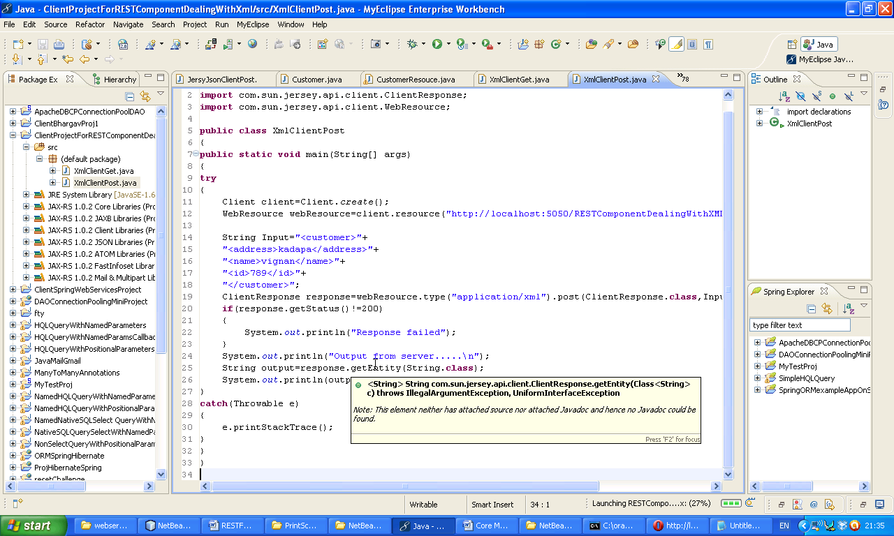

Now Right click on the XmlClientPost 🡪 Run As 🡪 Java Application

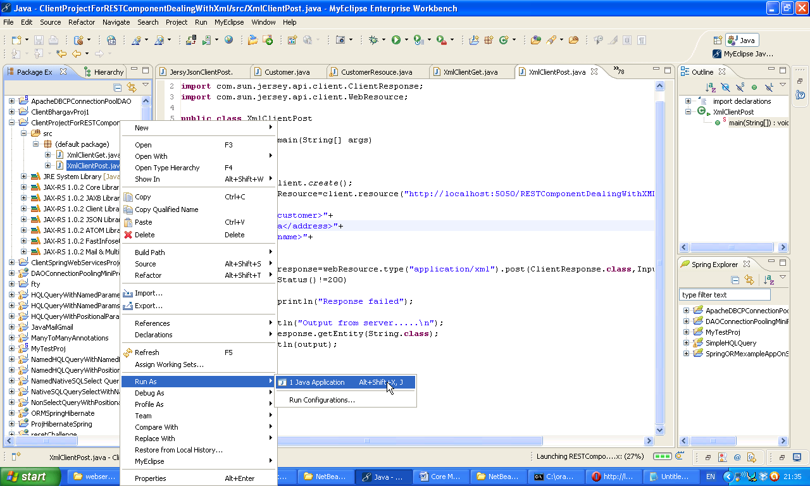Following window will appear. In this window we will get added column details. So check once your data base to ensure column insertion. So like this we can give XML input.